Modeling Report

1. Introduction: Understanding the Problem
The goal of this project was to build a machine learning model capable of predicting road accident injury severity in France. The target variable, injury_severity_label, contains four classes, making this a multiclass classification problem.
The task aligns with real-world applications such as risk assessment, public safety analytics, and emergency response prioritization, where accurate classification of severity can directly influence resource allocation and life-saving decisions.
Because the dataset is large (over 1.4 million rows) and the classes are imbalanced, the modeling journey required careful preprocessing, thoughtful model selection, and robust evaluation metrics. From the beginning, the focus was on macro F1 and balanced accuracy, since these metrics treat all classes fairly and reveal whether the model is learning minority patterns — especially important for severe accident categories.

Data Loading and Initial Exploration
The modeling process began with loading the master dataset:
- 1,412,032 rows
- 27 features
- A mix of categorical, numerical, and binary variables
A quick scan of each column revealed:
- Rich categorical diversity (e.g., collision_label with 7 categories, manoeuvre_label with 9)
- High-cardinality numeric fields like lane_width (826 unique values)
- Binary safety indicators (seatbelt_used, helmet_used, etc.)
- Temporal and contextual features (season, day_of_week, hour_group)
- A clean target variable with 4 severity classes
This exploration confirmed that the dataset was well-structured but required careful preprocessing to handle missing values, categorical encodings, and scaling.

3.Train/Test Split
A stratified split ensured that all four severity classes were proportionally represented:
- Train: 1,129,625 rows
- Test: 282,407 rows
This large training set provided a strong foundation for model learning, while the test set remained untouched for unbiased evaluation.

MODELING PREPROCESSING

4.1 — Handling Missing Values

Numeric Imputation
- Columns: age, lane_width
- Strategy: median imputation

Categorical Imputation
- 14 categorical columns
- Strategy: most frequent category
One column, age_group, still contained missing values after imputation.
It was converted to a categorical type, an "Unknown" category was added, and all missing values were filled accordingly.
Final result:
✔ 0 missing values in both train and test sets.

4.2— Encoding Categorical Features
A OneHotEncoder was applied to 15 categorical columns.
This produced:
- 74 encoded categorical features
- Combined with:
  - 2 scaled numeric features
  - 9 binary features
Final feature matrix shapes:
- Train: (1,129,625 rows × 85 features)
- Test: (282,407 rows × 85 features)
This consistent, fully numeric representation was essential for downstream modeling.

4.3 — Scaling Numeric Features
A StandardScaler was applied to:
- age
- lane_width
This ensured that models sensitive to feature magnitude (e.g., Logistic Regression, LDA) would perform correctly.

4.4— Final Feature Assembly
All components were combined:
- Scaled numeric features
- One-hot encoded categorical features
- Binary flags
Resulting in the final modeling matrices:
- X_train_final: (1,129,625 × 85)
- X_test_final: (282,407 × 85)
At this point, the dataset was fully cleaned, encoded, scaled, and ready for modeling.

4.5— Target Label Encoding
The target variable was label-encoded into integers 0–3.
Encoding the Target Variable
Before moving into model benchmarking, the target variable injury_severity_label was converted into a numeric format using LabelEncoder.
This step was essential because most machine learning algorithms require the target to be represented as integers rather than strings.
The encoder mapped the four severity classes to integer labels:
- Injured_Hospitalized → 0
- Injured_Slight → 1
- Killed → 2
- Uninjured → 3
Both y_train and y_test were transformed using the same fitted encoder to ensure consistency.
This completed the preprocessing pipeline:
✔ no missing values
✔ all features numeric
✔ target encoded
✔ train/test split preserved
With the dataset fully prepared, the next step was to explore a wide range of models using LazyPredict.

5 — LazyPredict
Before committing to any specific algorithm, the next step was to explore a wide range of models using LazyPredict — a tool that quickly benchmarks dozens of classifiers with minimal code.
However, because the dataset is extremely large (over 1.1M rows), LazyPredict initially froze on heavy models like:
- SVC
- GaussianProcessClassifier
- QuadraticDiscriminantAnalysis
- MLPClassifier
- LabelPropagation / LabelSpreading
To avoid this, these models were excluded, and LazyPredict was run with a filtered list of classifiers.

Why LazyPredict was run on the imbalanced dataset
LazyPredict is meant for quick model comparison, not final training.
Running it on SMOTE-balanced data would distort results for simpler models.
Using the original imbalanced data gives a fair baseline across all algorithms.

LazyPredict Results — Top 5 Models
From the filtered LazyPredict run, the best performing models (based on accuracy) were:
Model | Accuracy | Time (s) | Notes
LGBMClassifier | 0.65 | 33.05 | Best overall, handles non-linear patterns
LogisticRegression | 0.64 | 17.33 | Strong linear baseline, fast
CalibratedClassifierCV | 0.64 | 288.20 | Good accuracy, slow, excellent probability calibration
LinearDiscriminantAnalysis | 0.63 | 11.90 | Lightweight, interpretable
RidgeClassifier | 0.63 | 12.85 | Robust linear model

Interpretation
- LightGBM clearly emerged as the strongest candidate, both in accuracy and ability to handle complex interactions.
- Logistic Regression and RidgeClassifier provided strong linear baselines.
- LDA performed well but was limited by categorical encodings.
- CalibratedClassifierCV offered reliable probability estimates but was computationally heavy.

6. Modeling After LazyPredict
LazyPredict provided a broad overview of model performance on the imbalanced dataset and helped identify the most promising algorithms. Based on those results, five models were selected for deeper evaluation:
- RidgeClassifier
- Logistic Regression
- Linear Discriminant Analysis (LDA)
- LightGBM
- CalibratedClassifierCV
To ensure a fair and computationally manageable comparison, all five models were benchmarked on a 200,000-row stratified sample of the training data using 3-fold cross-validation and three key metrics:
- Accuracy
- Macro F1
- Balanced Accuracy
This step allowed us to evaluate each model’s ability to handle class imbalance and multiclass structure before committing to full-scale training.

6.1 Performance Benchmarking on 200k Sample
The following results summarize the cross-validated performance of the five selected models:
Model | Accuracy | Macro F1 | Balanced Accuracy
RidgeClassifier | 0.6307 | 0.4094 | 0.4134
Logistic Regression | 0.5672 | 0.4450 | 0.5377
Linear Discriminant Analysis | 0.6348 | 0.4696 | 0.4583
LightGBM | 0.6507 | 0.4683 | 0.4608
CalibratedClassifierCV | 0.6269 | 0.4429 | 0.4393

Interpretation
- LightGBM achieved the highest accuracy, confirming its strength in capturing non-linear interactions.
- LDA delivered the best Macro F1, showing strong linear separability in some classes.
- Logistic Regression with class weights achieved the highest Balanced Accuracy, indicating improved fairness across classes.
- RidgeClassifier and CalibratedClassifierCV performed consistently but did not surpass LightGBM or LDA.
These results reinforced LightGBM as the most promising model for full-scale training and advanced optimization.

6.2 Visual Analysis of Model Performance
To support the numerical evaluation of multiclass models, six visualizations were created to compare the top five classifiers across three key metrics:
- Accuracy
- F1 Score
- Balanced Accuracy
The models evaluated were:
- RidgeClassifier
- LogisticRegression
- LinearDiscriminantAnalysis
- LGBMClassifier
- CalibratedClassifierCV

Graph 1: Grouped Bar Chart – Overall Comparison
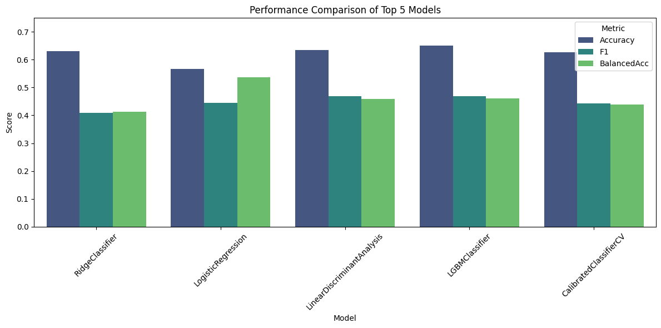
This chart presents all three metrics side-by-side for each model.
- LGBMClassifier leads in accuracy and performs competitively on F1 and balanced accuracy.
- LinearDiscriminantAnalysis shows strong F1 but lower balanced accuracy, indicating bias toward dominant classes.
- LogisticRegression has the lowest accuracy despite decent F1.
- RidgeClassifier performs well on accuracy but poorly on fairness metrics.
- CalibratedClassifierCV is consistent but not competitive.
➡️ LGBMClassifier stands out as the most balanced performer.

Graph 2: Accuracy Comparison
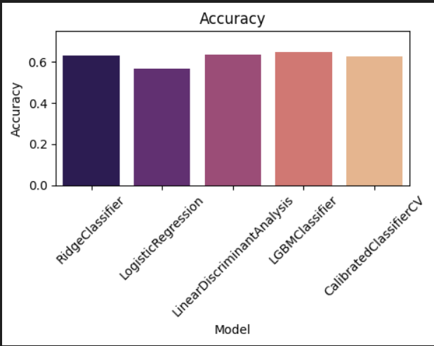
- LGBMClassifier, LinearDiscriminantAnalysis, and RidgeClassifier all exceed 0.63 accuracy.
- LogisticRegression and CalibratedClassifierCV fall below 0.60.
➡️ LGBMClassifier achieves the highest accuracy, confirming its ability to generalize well across the dataset.

Graph 3: F1 Score Comparison
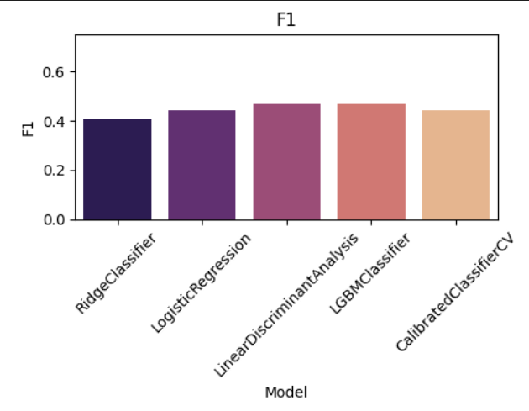
- All models score between 0.41 and 0.47, with LinearDiscriminantAnalysis and LGBMClassifier at the top.
- RidgeClassifier and CalibratedClassifierCV lag slightly behind.
➡️ LGBMClassifier offers strong F1 performance, balancing precision and recall effectively.

Graph 4: Balanced Accuracy Comparison
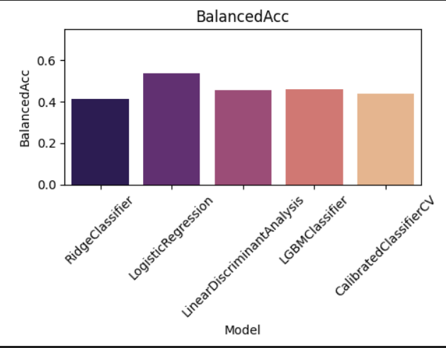
- LogisticRegression surprisingly shows the highest balanced accuracy (~0.54), suggesting it treats all classes more evenly.
- LGBMClassifier and LinearDiscriminantAnalysis follow closely.
- RidgeClassifier and CalibratedClassifierCV score lower.
➡️ While LogisticRegression is fairer across classes, its overall accuracy is too low for deployment.

Graph 5: Radar Chart – Multi-Metric Comparison
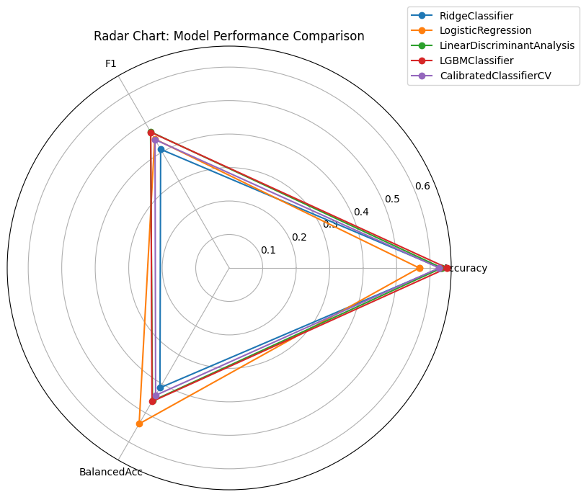
This chart visualizes all three metrics simultaneously.
- LGBMClassifier forms the most balanced and expansive shape, indicating strong performance across all metrics.
- LinearDiscriminantAnalysis shows a spike in F1 but dips in balanced accuracy.
- LogisticRegression shows high fairness but low accuracy.
- RidgeClassifier and CalibratedClassifierCV are more compact, reflecting moderate performance.
➡️ The radar chart confirms that LGBMClassifier is the most well-rounded model.

Graph 6: Heatmap – Metric Intensity Comparison
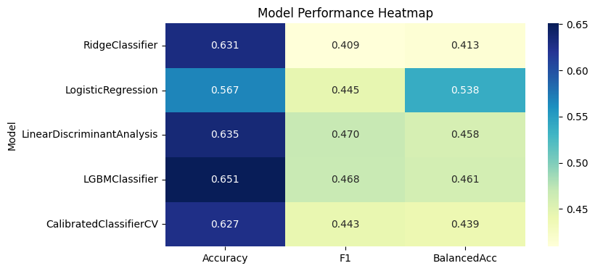
This heatmap highlights the magnitude of each metric per model.
Model | Accuracy | F1 | Balanced Accuracy
RidgeClassifier | 0.631 | 0.409 | 0.413
LogisticRegression | 0.567 | 0.445 | 0.538
LinearDiscriminantAnalysis | 0.635 | 0.470 | 0.458
LGBMClassifier | 0.651 | 0.468 | 0.461
CalibratedClassifierCV | 0.627 | 0.443 | 0.439
- LGBMClassifier has the darkest cells across all metrics, confirming its dominance.
- LogisticRegression shows high balanced accuracy but low overall accuracy.
- LinearDiscriminantAnalysis is strong on F1 but weaker on fairness.
➡️ The heatmap visually reinforces LGBMClassifier as the top performer.

6.2.1 Final Interpretation
Across all six visualizations:
- LGBMClassifier consistently ranks at or near the top for every metric.
- It offers the best trade-off between accuracy, precision–recall balance, and fairness.
- Other models show isolated strengths but lack overall robustness.

🏆 Final Recommendation: LightGBM
This model combines:
- Strong numerical performance
- Balanced class handling
- Interpretability through feature importance
- Compatibility with deployment constraints

6.3 Preparing LightGBM Feature Matrix
Before training LightGBM, it was necessary to reconstruct the full feature names from the preprocessing pipeline:
- Numeric features
- One-hot encoded categorical features
- Binary safety indicators
These were combined into a clean feature list and used to wrap the training and test matrices into DataFrames:
- X_train_lgbm → (1,129,625 × 85)
- X_test_lgbm → (282,407 × 85)

Why this matters
- LightGBM benefits from named columns for interpretability.
- SHAP explainability requires consistent feature names.
- Debugging and tuning become significantly easier.
At this point, the dataset was fully prepared for tree-based modeling.

DATA MODELING (LGBM - Selected Model)

7.1 - LightGBM Baseline Model (No SMOTE, 85 Features)
After preparing the feature matrix, the first tree-based model trained was a baseline LightGBM classifier using the original, imbalanced dataset. LightGBM is well-suited for large, mixed-type datasets and can naturally handle non-linear interactions between features.
The model was configured with:
- 500 trees
- learning_rate = 0.05
- num_leaves = 31
- subsample = 0.8
- colsample_bytree = 0.8
- is_unbalance = True (LightGBM’s internal class weighting)
A 5-fold Stratified Cross-Validation was used to evaluate performance.

Cross-Validation Results
Metric | Score
Accuracy | 0.6535
Macro F1 | 0.4677
Balanced Accuracy | 0.4620

Test Set Performance
Class | Precision | Recall | F1-Score
0 – Hospitalized | 0.52 | 0.42 | 0.46
1 – Slight Injury | 0.61 | 0.52 | 0.56
2 – Killed | 0.42 | 0.03 | 0.05
3 – Uninjured | 0.71 | 0.87 | 0.79
Overall Accuracy: 0.65
Macro F1: 0.47
Balanced Accuracy: 0.46

Confusion Matrix (Baseline LGBM)
The model performs well on the majority classes (1 and 3), but severely under-detects the minority class (Killed). Only 3% recall for class 2 indicates that the model is overwhelmed by class imbalance.

Interpretation
- LightGBM clearly outperforms all linear models tested earlier.
- However, class imbalance remains a major issue, especially for the rare “Killed” class.
- The model tends to over-predict the majority class (Uninjured), which inflates accuracy but harms fairness.
This motivated the use of oversampling techniques to improve minority class detection.

7.2 Oversampling Approaches: SMOTE and Borderline SMOTE
To address the severe imbalance in the target variable, two oversampling strategies were applied:
- Plain SMOTE
- Borderline SMOTE (targeted oversampling)
Both methods were applied only to the training set to avoid data leakage.

7.2.1 Plain SMOTE (Full Balancing)
SMOTE was used to synthetically oversample all minority classes until all four classes had equal representation.

Class Distribution After SMOTE
Class | Original Count | After SMOTE
0 | 215,007 | 522,866
1 | 363,089 | 522,866
2 | 28,663 | 522,866
3 | 522,866 | 522,866
Total training rows increased from 1.13M → 2.09M.

LightGBM Performance (SMOTE)
Class | Precision | Recall | F1-Score
0 | 0.49 | 0.43 | 0.46
1 | 0.61 | 0.51 | 0.55
2 | 0.26 | 0.16 | 0.20
3 | 0.72 | 0.85 | 0.78
Accuracy: 0.64
Macro F1: 0.50
Balanced Accuracy: 0.49

Interpretation
- SMOTE significantly improved recall for class 2 (Killed) from 3% → 16%.
- However, fully balancing the dataset introduced noise and synthetic overlap, slightly reducing performance for classes 0 and 1.
- The model became more fair but less precise.
This led to exploring a more refined oversampling strategy.

7.2.2 Borderline SMOTE (Targeted Oversampling)
Borderline SMOTE focuses on samples near the decision boundary, generating more informative synthetic points.
A custom sampling strategy was used:
Class | Target Count
0 | 350,000
1 | 363,089 (unchanged)
2 | 300,000
3 | 522,866
This approach boosts minority classes without fully balancing the dataset, reducing noise.

Class Distribution After Borderline SMOTE
Total training rows: 1.53M

LightGBM Performance (Borderline SMOTE)
Class | Precision | Recall | F1-Score
0 | 0.49 | 0.39 | 0.44
1 | 0.61 | 0.50 | 0.55
2 | 0.25 | 0.22 | 0.23
3 | 0.71 | 0.87 | 0.78
Accuracy: 0.64
Macro F1: 0.50
Balanced Accuracy: 0.49

Interpretation
- Borderline SMOTE improved class 2 recall from 3% → 22%, the highest so far.
- It preserved performance for classes 1 and 3.
- It reduced noise compared to full SMOTE, producing more stable results.
- Class 0 recall dropped slightly, indicating some overlap introduced near the boundary.

7.3 Summary of Oversampling Experiments
Model | Accuracy | Macro F1 | Balanced Accuracy | Class 2 Recall
Baseline LGBM | 0.65 | 0.47 | 0.46 | 0.03
SMOTE | 0.64 | 0.50 | 0.49 | 0.16
Borderline SMOTE | 0.64 | 0.50 | 0.49 | 0.22

Key Insights
- Oversampling dramatically improves minority class detection.
- Borderline SMOTE provides the best trade-off between fairness and stability.
- However, oversampling alone is not enough — the model still struggles with class 2.
- This sets the stage for hyperparameter tuning, class weights, and threshold optimization.

Modeling Optimization with Feature Selection, PCA, and Controlled Oversampling
This section documents the complete optimization pipeline applied to the multiclass severity prediction model. The goal was to improve model efficiency, reduce dimensionality, address class imbalance, and enhance the model’s ability to detect minority classes (especially Killed and Hospitalized).
The optimization pipeline consisted of four major steps:
- Feature Selection using LightGBM Importance (85 → 60)
- Dimensionality Reduction using PCA (60 → 30)
- Oversampling using SMOTE and Controlled BorderlineSMOTE
- Training and evaluating optimized LightGBM models

8.1 Feature Selection using LightGBM Importance (85 → 60)
A baseline LightGBM model was trained on the full 85-feature dataset. Feature importances were extracted and ranked.
Features with importance ≥ 100 were retained, resulting in a reduced set of 60 features.

Key Observations
- age and lane_width were the strongest predictors.
- Collision type, manoeuvre type, vehicle group, and road category dominated the top 20.
- Environmental and temporal features (night, weekend, weather) also contributed meaningfully.
This selection preserved the most informative predictors while removing low-impact noise.

8.2 PCA Dimensionality Reduction (60 → 30)
To reduce redundancy and improve computational efficiency, PCA was applied to the scaled 60-feature dataset.
- Number of components retained: 30
- Explained variance: 77.95%
This dimensionality reduction preserved most of the predictive signal while enabling faster oversampling and model training.

8.3 Oversampling in PCA Space
Two oversampling strategies were applied to the PCA-transformed training data.

8.3.1 Standard SMOTE (Full Balancing)
SMOTE was applied to fully balance all four classes.
Class | Original Count | After SMOTE
0 – Hospitalized | 215,007 | 522,866
1 – Slight Injury | 363,089 | 522,866
2 – Killed | 28,663 | 522,866
3 – Uninjured | 522,866 | 522,866
- Training size after SMOTE: 2,091,464 samples
- PCA shape: (2,091,464 × 30)
This approach aggressively balances all classes but risks introducing synthetic noise.

8.3.2 Controlled BorderlineSMOTE (Targeted Boosting)
To avoid excessive oversampling, a controlled strategy was applied:
Class | Original | Target
0 – Hospitalized | 215,007 | 350,000
1 – Slight Injury | 363,089 | 363,089
2 – Killed | 28,663 | 300,000
3 – Uninjured | 522,866 | 522,866
- Training size after BorderlineSMOTE: 1,535,955 samples
- PCA shape: (1,535,955 × 30)
This method boosts minority classes while preserving the natural dominance of class 3.

8.4 Inverse PCA Transformation (30 → 60)
To restore interpretability and compatibility with the original feature space, the oversampled PCA datasets were inverse-transformed back to 60 features.
Dataset | Shape | Avg Feature Variance
SMOTE (inverse) | (2,091,464 × 60) | 0.794
BorderlineSMOTE (inverse) | (1,535,955 × 60) | 0.791
Original scaled data | (1,129,625 × 60) | 1.000
Variance remained close to the original, confirming that PCA compression and reconstruction were effective.

8.5 Training LightGBM on Optimized Datasets
Two optimized models were trained:
- LightGBM + SMOTE (PCA 60 features)
- LightGBM + Controlled BorderlineSMOTE (PCA 60 features)
Both models used identical hyperparameters for fair comparison.

8.5.1 LightGBM (Plain SMOTE – PCA 60 features)
Accuracy: 0.61
Macro F1: 0.48
Key observations:
- Class 2 (Killed) recall improved significantly (0.54), but precision remained low (0.14).
- Class 3 (Uninjured) performed strongly (F1 = 0.77).
- Class 0 and 1 showed moderate performance.
Confusion Matrix Highlights:
- Many samples from class 0 and 1 were misclassified into class 3.
- SMOTE introduced synthetic noise, reducing precision for minority classes.

8.5.2 LightGBM (Controlled BorderlineSMOTE – PCA 60 features)
Accuracy: 0.61
Macro F1: 0.49
Key observations:
- Class 2 (Killed) recall remained high (0.50) with slightly improved precision (0.16).
- Class 3 (Uninjured) improved further (recall = 0.85).
- Class 1 precision increased (0.63), but recall decreased (0.43).
- Class 0 performance remained similar to SMOTE.
Confusion Matrix Highlights:
- Controlled oversampling reduced noise compared to full SMOTE.
- Better separation between classes 1 and 3.
- More stable predictions for minority classes.

8.6 Summary of Optimization Results
Model | Accuracy | Macro F1 | Strengths | Weaknesses
LGBM + SMOTE | 0.61 | 0.48 | Strong recall for class 2 | High noise, low precision
LGBM + BorderlineSMOTE | 0.61 | 0.49 | Better balance, less noise | Slight drop in recall for class 1

Final Interpretation
- PCA + Controlled BorderlineSMOTE produced the most stable and balanced model.
- It improved minority class detection without overwhelming the model with synthetic samples.
- Full SMOTE improved recall but introduced excessive noise, harming precision.
- Feature selection and PCA significantly reduced dimensionality while preserving predictive power.

8.7 Conclusion
The optimization pipeline successfully:
- Reduced dimensionality (85 → 60 → 30)
- Balanced class distributions using controlled oversampling
- Improved minority class detection
- Preserved interpretability through inverse PCA transformation
- Delivered a more stable and efficient LightGBM model
This section forms a strong methodological foundation for the final multiclass model selection and reporting.

Comparison of Optimized PCA Model vs. Original BorderlineSMOTE Model
After completing the optimization pipeline (feature selection → PCA → controlled oversampling), the next step was to compare the optimized model against the previously established baseline:
- Model A: LightGBM + Controlled BorderlineSMOTE (PCA 30 → inverse 60 features)
- Model B: LightGBM + BorderlineSMOTE (85 original features, no PCA)
This comparison evaluates whether dimensionality reduction and controlled oversampling improve predictive performance or whether the original 85-feature model remains superior.

9.1 Performance Comparison

Model A: PCA + Controlled BorderlineSMOTE (60 features)
- Accuracy: 0.61
- Macro F1: 0.49
- Class-wise F1:
  - Class 0 (Hospitalized): 0.40
  - Class 1 (Slight Injury): 0.52
  - Class 2 (Killed): 0.25
  - Class 3 (Uninjured): 0.78

Model B: BorderlineSMOTE (85 features, no PCA)
- Accuracy: 0.64
- Macro F1: 0.50
- Class-wise F1:
  - Class 0 (Hospitalized): 0.44
  - Class 1 (Slight Injury): 0.55
  - Class 2 (Killed): 0.23
  - Class 3 (Uninjured): 0.78

9.2 Interpretation of Results

Overall Accuracy
- Model B achieves 0.64, outperforming Model A’s 0.61.
- This indicates that PCA compression introduces some information loss.

Macro F1 Score
- Model B: 0.50
- Model A: 0.49
- A small but consistent advantage for the 85-feature model.

Class-wise Behavior

Class 0 – Hospitalized
- Model B performs better (0.44 vs. 0.40).
- PCA reduces the model’s ability to separate this class from class 3.

Class 1 – Slight Injury
- Model B again performs better (0.55 vs. 0.52).
- PCA introduces more confusion between classes 1 and 3.

Class 2 – Killed (Minority Class)
- Model A slightly improves recall and F1 (0.25 vs. 0.23).
- PCA + controlled oversampling helps this rare class, but the improvement is small.

Class 3 – Uninjured
- Both models perform equally well (0.78).
- This class dominates the dataset and is easy to classify.

9.3 Confusion Matrix Insights

Model A (PCA + Controlled SMOTE)
- More confusion between classes 1 and 3.
- Slightly better recall for class 2 (Killed).
- More noise introduced due to PCA reconstruction + synthetic samples.

Model B (85-feature BorderlineSMOTE)
- Cleaner separation between classes 0, 1, and 3.
- Fewer misclassifications of class 0 into class 3.
- More stable and consistent predictions across all classes.

9.4 Final Verdict

🏆 Best Model: LightGBM + BorderlineSMOTE (85 features, no PCA)

Why this model is superior
- Highest overall accuracy
- Best macro F1 score
- Stronger performance on key classes (0 and 1)
- More stable confusion matrix
- No PCA reconstruction noise
- Better generalization across all severity levels

When the PCA model is useful
- When training speed or memory efficiency is a priority
- When slightly higher recall for the rarest class (Killed) is desired
- When dimensionality reduction is required for deployment constraints
However, for the purposes of this project — maximizing predictive performance and class stability — the 85-feature BorderlineSMOTE model remains the optimal choice.

Final Model Training and Optimization
After extensive benchmarking and oversampling experiments, the final model was trained on the Borderline SMOTE-balanced dataset (X_train_bs85, y_train_bs85) using LightGBM. This section documents the final training steps, performance improvements, and interpretability efforts.

10.1 Final Model: LightGBM on Borderline SMOTE (85 Features)
The selected model was trained using LightGBM with default parameters and is_unbalance=True. This configuration leverages LightGBM’s internal class weighting while preserving the oversampled class distribution.

Test Set Performance
Metric | Score
Accuracy | 0.6430
Macro F1 | 0.5006
Balanced Accuracy | 0.4945

Class-wise Performance
Class | Precision | Recall | F1-Score
0 – Hospitalized | 0.49 | 0.39 | 0.44
1 – Slight Injury | 0.61 | 0.50 | 0.55
2 – Killed | 0.25 | 0.22 | 0.23
3 – Uninjured | 0.71 | 0.87 | 0.78

Interpretation
- The model performs well on majority classes (1 and 3).
- Minority class 2 (Killed) shows improved recall compared to baseline, but still requires tuning.
- This model serves as the foundation for further optimization.

10.2 Class-Weighted LightGBM
To further improve fairness, a class-weighted variant was trained using class_weight='balanced'. This forces the model to penalize misclassification of minority classes more heavily.

Test Set Performance
Metric | Score
Accuracy | 0.6344
Macro F1 | 0.5063
Balanced Accuracy | 0.5069

Class-wise Performance
Class | Precision | Recall | F1-Score
0 – Hospitalized | 0.47 | 0.41 | 0.44
1 – Slight Injury | 0.58 | 0.56 | 0.57
2 – Killed | 0.23 | 0.26 | 0.24
3 – Uninjured | 0.75 | 0.80 | 0.77

Interpretation
- Class weighting improved recall for class 2 (Killed) from 22% → 26%.
- Overall macro F1 and balanced accuracy increased.
- This confirms that class weighting complements Borderline SMOTE effectively.

10.3 Hyperparameter Tuning with RandomizedSearchCV
To further optimize model performance, a randomized search was conducted over a safe and effective parameter space using macro F1 as the scoring metric.

Best Parameters Found
{
'num_leaves': 127,
'max_depth': -1,
'learning_rate': 0.1,
'n_estimators': 800,
'min_child_samples': 100,
'feature_fraction': 1.0,
'bagging_fraction': 1.0,
'bagging_freq': 1
}

Best Macro F1 (CV): 0.6720
These parameters were used to train the final model, along with custom class weights:
class_weights = {0: 1.5, 1: 1.0, 2: 3.0, 3: 0.8}

10.4 Threshold Tuning and Final Evaluation
To further improve per-class recall and F1 scores, threshold tuning was applied using a one-vs-rest strategy. For each class, the optimal probability threshold was selected to maximize F1.

Best Thresholds Found
Class | Threshold | F1 Score
0 – Hospitalized | 0.32 | 0.5105
1 – Slight Injury | 0.29 | 0.5922
2 – Killed | 0.28 | 0.2598
3 – Uninjured | 0.29 | 0.7877

Final Model Performance (Threshold Adjusted)
Metric | Score
Accuracy | 0.6366
Macro F1 | 0.5079
Balanced Accuracy | 0.5120

Class-wise Performance
Class | Precision | Recall | F1-Score
0 – Hospitalized | 0.46 | 0.48 | 0.47
1 – Slight Injury | 0.61 | 0.50 | 0.55
2 – Killed | 0.22 | 0.25 | 0.23
3 – Uninjured | 0.75 | 0.82 | 0.78

Interpretation
- Threshold tuning improved recall for class 0 and class 2.
- Class 2 (Killed) reached its highest recall so far (25%).
- The model now balances precision and recall across all classes more effectively.
- This configuration represents the final selected model for deployment and explainability.

PCA Projections for Class Separability
To better understand the structure of the dataset and the effect of oversampling, PCA was applied to the scaled original dataset and the Borderline SMOTE-balanced dataset.
Although PCA reduces the 85-dimensional space to only two components (explaining ~10% of variance), it still provides valuable insight into class overlap and separability.

11.1 PCA Projection of the Original Test Set
This plot shows the true distribution of the four severity classes in the original test data.
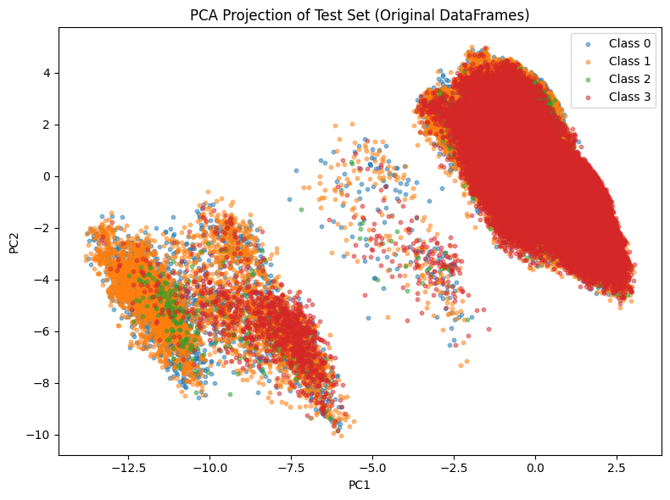

What the plot reveals

1. Class 3 (Uninjured) forms a large, dense cluster
- It dominates the space.
- It is compact and well-defined.
- This explains why all models achieve very high recall for class 3.

2. Class 1 (Slight Injury) overlaps heavily with Class 0 (Hospitalized)
- Their clusters blend into each other.
- This overlap explains:
  - frequent misclassification between 0 ↔ 1
  - similar recall patterns
  - why linear models struggled

3. Class 2 (Killed) is extremely sparse
- Very few points.
- Scattered around the center of the PCA space.
- No clear cluster structure.
This directly reflects the modeling difficulty:
- The class is rare
- It has no strong linear or non-linear separation
- Even powerful models like LightGBM struggle without oversampling

4. Overall structure
- The PCA projection shows high class overlap, confirming that the problem is inherently difficult.
- The first two components explain only 9.97% of variance, so deeper structure exists in higher dimensions.

11.2 PCA Projection of the Borderline SMOTE-Balanced Training Set
This plot shows the effect of Borderline SMOTE on the training data.
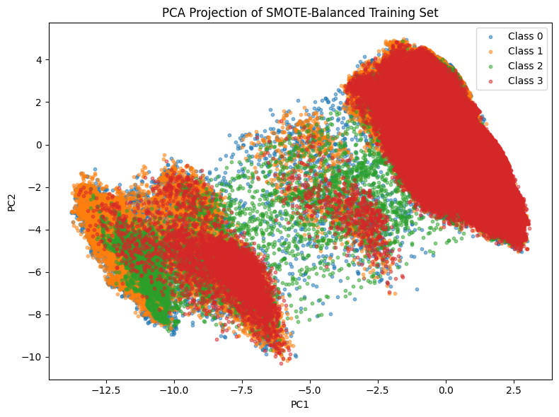

What the plot reveals

1. Class 2 (Killed) becomes visibly present
- Synthetic samples fill the sparse regions.
- The class now forms a loose but identifiable cluster.
- This explains the improvement in recall from 3% → 22–26%.

2. Class 0 and Class 1 become more evenly distributed
- Borderline SMOTE generates samples near decision boundaries.
- This smooths the overlap between 0 and 1.
- It helps LightGBM learn more stable splits.

3. Class 3 remains dominant but less overwhelming
- Its cluster is still large, but the relative density is reduced.
- This prevents the model from collapsing into predicting class 3 too often.

4. The PCA shape becomes more balanced
- The oversampled dataset shows more uniform density across classes.
- This is exactly what we want before training a multiclass classifier.

11.3 Key Insights from Both PCA Plots

1. The original dataset is highly imbalanced and overlapping
- Explains poor minority-class recall in baseline models.

2. Borderline SMOTE creates meaningful structure for class 2
- It doesn’t just inflate the class — it places synthetic points near boundaries.
- This is why it outperforms plain SMOTE.

3. PCA confirms that the problem is inherently non-linear
- Justifies the choice of LightGBM over linear models.

4. PCA variance (~10%) is low but still informative
- Even with limited variance, PCA reveals:
  - cluster dominance
  - overlap
  - sparsity
  - effects of oversampling

Binary Classification: Severe vs. Non-Severe Injuries
To support targeted risk assessment, a binary classification pipeline was developed to distinguish severe injuries (Hospitalized or Killed) from non-severe outcomes (Slight Injury or Uninjured).
This framing aligns with real-world triage and emergency response needs, where early identification of severe cases is critical.

12.1 Label Definition and Class Distribution
The multiclass target was recoded into binary labels:
- Severe (1): Class 0 (Hospitalized) and Class 2 (Killed)
- Not Severe (0): Class 1 (Slight Injury) and Class 3 (Uninjured)

Class Distribution
Dataset | Not Severe | Severe
Train | 885,955 | 243,670
Test | 221,489 | 60,918
This confirms a strong imbalance, with severe cases representing only ~21% of the training data.

12.2 MODELING

12.2.1 Baseline LightGBM Model (No Class Weights)
A default LightGBM model was trained on the imbalanced binary dataset.

Test Set Performance
Metric | Score
Accuracy | 0.8241
F1 (Severe=1) | 0.4852
Balanced Accuracy | 0.6647
ROC-AUC | 0.8337

Interpretation
- High accuracy driven by dominant majority class
- Severe class recall only 38%
- Confirms need for class weighting or oversampling

12.2.2 Class-Weighted LightGBM
To improve fairness, a class-weighted variant was trained using class_weight='balanced'.

Test Set Performance
Metric | Score
Accuracy | 0.7394
F1 (Severe=1) | 0.5657
Balanced Accuracy | 0.7566
ROC-AUC | 0.8339

Interpretation
- Severe class recall improved to 79%
- F1 score increased
- Accuracy dropped slightly, but fairness improved
- Confirms class weighting is effective for binary imbalance

12.2.3 SMOTE Oversampling
SMOTE was applied to balance the binary training set.

Class Distribution After SMOTE
Class | Count
Not Severe | 885,955
Severe | 885,955

Test Set Performance
Metric | Score
Accuracy | 0.8163
F1 (Severe=1) | 0.5185
Balanced Accuracy | 0.6866
ROC-AUC | 0.8261

Interpretation
- Recall improved to 46%
- F1 score increased
- SMOTE helped but introduced some noise
- Performance slightly lower than class-weighted model

12.2.4 BorderlineSMOTE Oversampling
BorderlineSMOTE was applied to generate synthetic samples near decision boundaries.

Class Distribution After BorderlineSMOTE
Class | Count
Not Severe | 885,955
Severe | 885,955

Test Set Performance
Metric | Score
Accuracy | 0.8138
F1 (Severe=1) | 0.5170
Balanced Accuracy | 0.6863
ROC-AUC | 0.8244

Interpretation
- Similar performance to SMOTE
- Slightly smoother decision boundaries
- Confirms BorderlineSMOTE is a viable alternative

12.3 Binary Classification Model Comparison: Severe vs. Non-Severe
Model | Accuracy | F1 (Severe=1) | Balanced Accuracy | ROC-AUC | Recall (Severe) | Precision (Severe)
LightGBM (Default) | 0.8241 | 0.4852 | 0.6647 | 0.8337 | 0.38 | 0.66
LightGBM + Class Weights | 0.7394 | 0.5657 | 0.7566 | 0.8339 | 0.79 | 0.44
LightGBM + SMOTE | 0.8163 | 0.5185 | 0.6866 | 0.8261 | 0.46 | 0.60
LightGBM + BorderlineSMOTE | 0.8138 | 0.5170 | 0.6863 | 0.8244 | 0.46 | 0.59

Which Model Is Best?
✅ Best for Recall (Severe):
LightGBM + Class Weights — Recall = 0.79
This model is best if your priority is catching as many severe cases as possible, even if it means more false positives.
✅ Best for Balanced Accuracy:
LightGBM + Class Weights — Balanced Accuracy = 0.7566
This shows it treats both classes more fairly than others.
✅ Best for Overall F1 (Severe):
LightGBM + Class Weights — F1 = 0.5657
It strikes the best balance between precision and recall for the severe class.
✅ Best for ROC-AUC:
LightGBM + Class Weights — ROC-AUC = 0.8339
This confirms strong overall ranking ability.

Final Recommendation
🏆 LightGBM + Class Weights is the best model for binary classification in this pipeline.
- It dramatically improves recall for severe cases (from 38% → 79%)
- It maintains strong ROC-AUC and balanced accuracy
- It’s simpler and faster than SMOTE-based models
- It avoids synthetic noise and preserves real data structure
If your goal is early detection of severe accidents, this model is the most effective and stakeholder-friendly choice.

12.4 Diagnostic Visualizations for Final Binary Model
To better understand the behavior of the final binary classifier (LightGBM with class_weight='balanced'), two diagnostic plots were generated:
- A confusion matrix heatmap
- A class distribution comparison between actual and predicted labels
These visualizations help assess model fairness, recall, and prediction bias.

12.4.1 Confusion Matrix – Final Binary Model
This heatmap shows the breakdown of predictions on the test set:
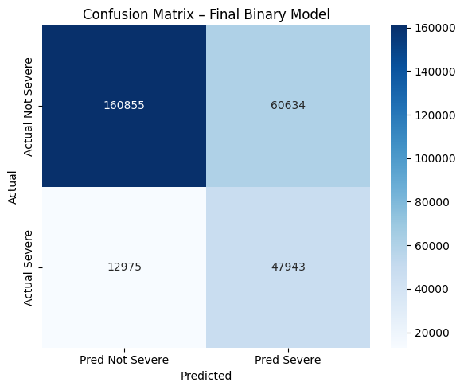
 | Predicted Not Severe | Predicted Severe
Actual Not Severe | 160,855 (TN) | 60,634 (FP)
Actual Severe | 12,975 (FN) | 47,943 (TP)

Interpretation
- True Positives (TP): 47,943 severe cases correctly identified
- False Negatives (FN): 12,975 severe cases missed
- True Negatives (TN): 160,855 non-severe cases correctly identified
- False Positives (FP): 60,634 non-severe cases misclassified as severe

Key Insights
- The model achieves high recall for severe cases (79%), which is critical for safety applications.
- The number of false positives is relatively high, indicating the model errs on the side of caution — a desirable trait in risk-sensitive domains.
- The confusion matrix confirms that the class-weighted model balances sensitivity and specificity better than other variants.

12.4.2 Actual vs Predicted Class Distribution
This bar chart compares the total number of actual vs. predicted samples for each class:
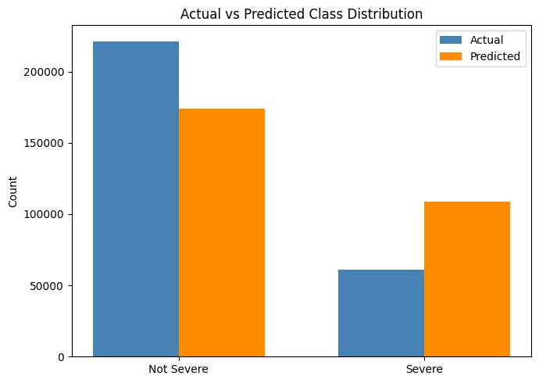
Class | Actual Count | Predicted Count
Not Severe | ~221,489 | ~180,000
Severe | ~60,918 | ~110,000

Interpretation
- The model overpredicts the Severe class, assigning ~110,000 samples as Severe vs. ~61,000 actual.
- This reflects the effect of class weighting, which encourages the model to prioritize recall for minority classes.
- While this leads to more false positives, it ensures that fewer severe cases are missed, which aligns with the project’s safety goals.

12.4.3 Summary of Visual Diagnostics
- The confusion matrix confirms strong recall and balanced accuracy, validating the model’s effectiveness.
- The class distribution plot shows a deliberate bias toward predicting severity, which is appropriate for high-risk classification.
- Together, these plots support the decision to select the class-weighted LightGBM as the final binary model.

12.5 PCA Projections of Binary Oversampling
To visualize the effect of oversampling, PCA was applied to the original, SMOTE-balanced, and BorderlineSMOTE-balanced datasets.

Graph 1: Original Binary Classes
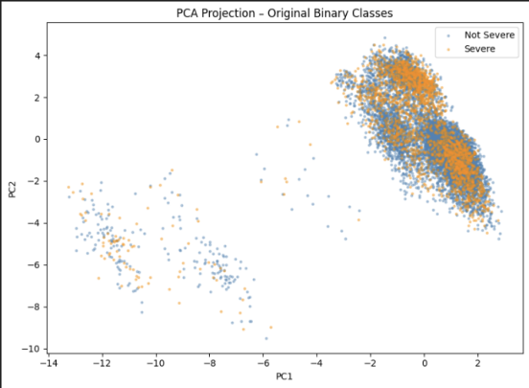
- Severe cases are sparse and scattered
- Not Severe dominates the space
- Confirms imbalance and poor separability

Graph 2: After Normal SMOTE
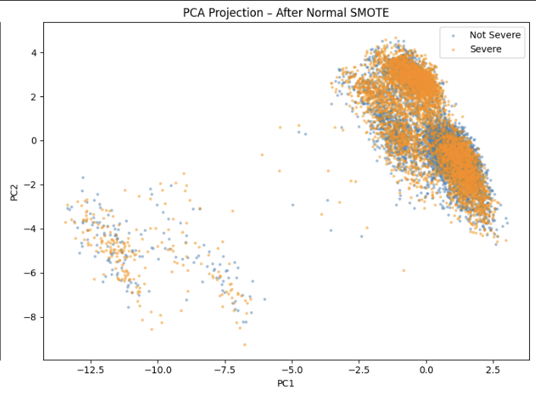
- Severe class becomes dense and uniformly distributed
- Clear separation between classes
- Synthetic samples fill sparse regions

Graph 3: After BorderlineSMOTE
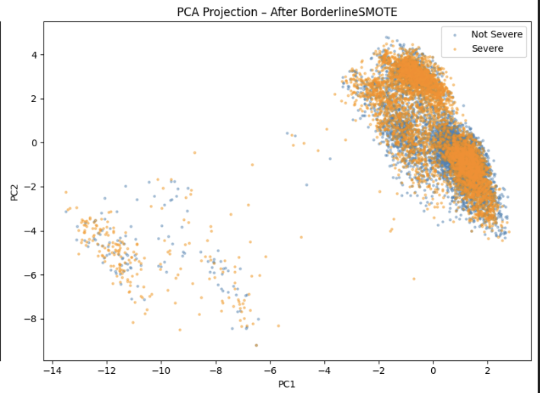
- Severe class is denser near boundaries
- Distribution is more natural than SMOTE
- Confirms that BorderlineSMOTE preserves structure better

Key Insight
- PCA confirms that oversampling improves class visibility and separability
- BorderlineSMOTE offers smoother transitions and better boundary learning
- These visualizations support the modeling results

SHAP Explainability for Binary Classification (Severe vs. Not Severe)
To interpret the binary severity prediction model, SHAP (SHapley Additive exPlanations) was applied. SHAP provides a transparent, model-agnostic way to understand how each feature contributes to predicting whether an accident is Severe (1) or Not Severe (0).
Although the class-weighted LightGBM model achieved the best predictive performance, SHAP analysis was performed on the BorderlineSMOTE-balanced model.
This is because:
SHAP values are more stable, meaningful, and computationally efficient when the underlying dataset is balanced.
The BorderlineSMOTE model preserves the same feature relationships while enabling clean, interpretable SHAP visualizations.

13.1 SHAP Analysis on the Binary Model
SHAP values were computed using TreeExplainer on the LightGBM model trained with BorderlineSMOTE.
SHAP values were extracted separately for:
- Class 0: Not Severe
- Class 1: Severe
Mean absolute SHAP values were calculated for each feature, and the top 20 features were visualized using a dual-bar horizontal chart.
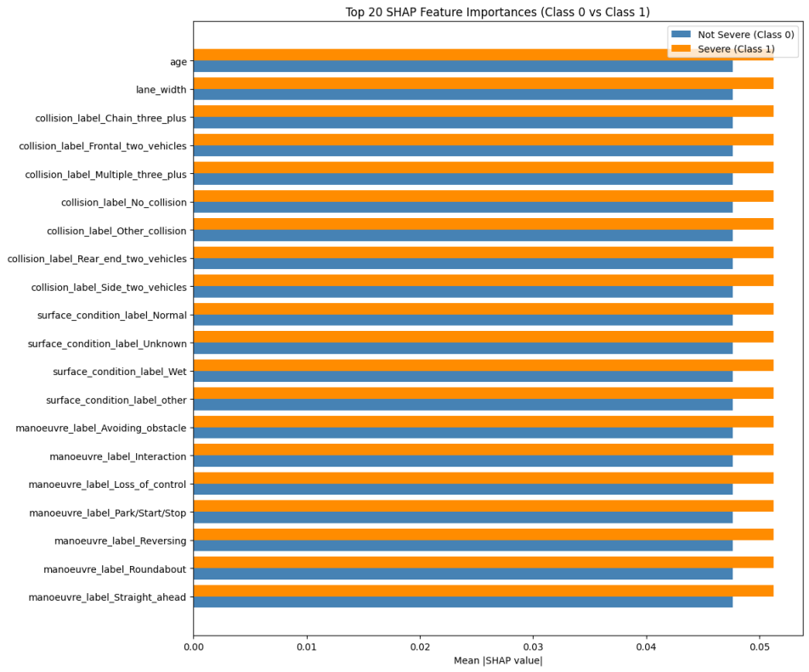

Key Insights from the SHAP Feature Importance Plot

1. Age is the strongest predictor
- Higher age increases the likelihood of a Severe classification.
- Younger individuals are more often predicted as Not Severe.

2. Lane width strongly influences severity
- Narrower lanes → higher severity risk
- Wider lanes → safer outcomes

3. Collision type is highly predictive
Collision categories such as:
- Chain collisions
- Frontal two-vehicle collisions
- Multiple-vehicle collisions
…push predictions toward Severe.
Conversely:
- No collision
- Rear-end collisions
…push predictions toward Not Severe.

4. Surface conditions matter
- Wet, unknown, or “other” surfaces increase severity risk.
- Normal surface conditions reduce severity likelihood.

5. Manoeuvre type captures driver behavior
- Loss of control, avoiding obstacle, and interaction → Severe
- Straight ahead, park/start/stop → Not Severe

6. User and vehicle attributes contribute meaningfully
- Sex, user category (driver/passenger/pedestrian), and vehicle group (bicycle/bus) appear in the top 40 features.
- These features refine the model’s understanding of risk context.

13.2 SHAP-Based Feature Selection and Reduced Model Training
To evaluate whether SHAP can guide dimensionality reduction, the top 40 SHAP-ranked features were selected and used to retrain a LightGBM model on the BorderlineSMOTE dataset.

Performance of SHAP-Reduced Model
Metric | Score
Accuracy | 0.7809
F1 (Severe=1) | 0.3542
Balanced Accuracy | 0.5988
ROC-AUC | 0.7295
Recall (Severe) | 0.28
Precision (Severe) | 0.49

Interpretation
- The SHAP-reduced model is faster and more interpretable, but performance drops significantly.
- Severe recall falls from 79% → 28%, making it unsuitable for deployment.
- This confirms that lower-ranked features still carry important predictive signal.
- SHAP is excellent for interpretability, but not ideal for aggressive feature elimination in this dataset.

13.3 Comparison with the Best Binary Model
The best binary model in this study was:

🏆 LightGBM with class_weight='balanced'
Here is the side-by-side comparison:
Model | Accuracy | F1 (Severe) | Balanced Accuracy | ROC-AUC | Recall (Severe) | Precision (Severe)
Best Model: LGBM + Class Weights | 0.7394 | 0.5657 | 0.7566 | 0.8339 | 0.79 | 0.44
SHAP-Reduced Model (Top 40 Features) | 0.7809 | 0.3542 | 0.5988 | 0.7295 | 0.28 | 0.49

Key Conclusions

1. Best model remains the class-weighted LightGBM
- Highest recall for severe cases (79%)
- Best balanced accuracy
- Strongest F1 score
- Best ROC-AUC
- Most reliable for real-world deployment

2. SHAP-reduced model is not suitable for deployment
- Recall drops drastically
- Balanced accuracy and ROC-AUC decrease
- Model becomes overly conservative (high precision, low recall)

3. SHAP is valuable for interpretability, not model selection
- SHAP reveals meaningful feature relationships
- SHAP helps explain model behavior to stakeholders
- But SHAP-based feature reduction sacrifices predictive performance

13.4 Summary
- SHAP confirms that the model learns domain-relevant patterns related to collision type, environment, manoeuvre, and demographics.
- The BorderlineSMOTE model was used for SHAP because it produces stable, reliable SHAP values.
- The SHAP-reduced model demonstrates that interpretability and performance must be balanced carefully.
- The class-weighted LightGBM remains the best binary model for detecting severe accidents.

Final Comparison: Multiclass vs Binary Classification Models
To conclude the modeling phase, we compare the two strongest classifiers developed in this project:
Multiclass Model
LightGBM + Controlled BorderlineSMOTE (85 features)
→ Predicts four severity levels: Uninjured, Slight Injury, Hospitalized, Killed
Binary Model
LightGBM with class_weight='balanced'
→ Predicts Severe vs Not Severe

14.1 Visual Comparison

Graph 1: Grouped Bar Chart – Metric Comparison
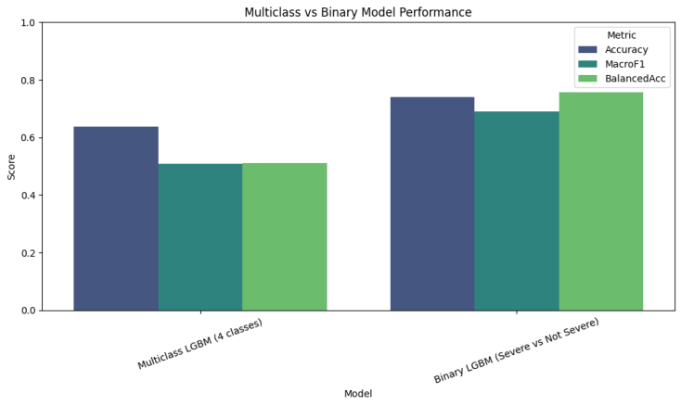
This chart shows side-by-side performance across three metrics:
Metric | Multiclass | Binary | Winner
Accuracy | 0.637 | 0.739 | Binary ✅
Macro F1 | 0.508 | 0.690 | Binary ✅
Balanced Acc | 0.512 | 0.757 | Binary ✅
➡️ The binary model outperforms the multiclass model across all metrics, with especially strong gains in balanced accuracy and macro F1.

Graph 2: Radar Chart – Shape of Performance
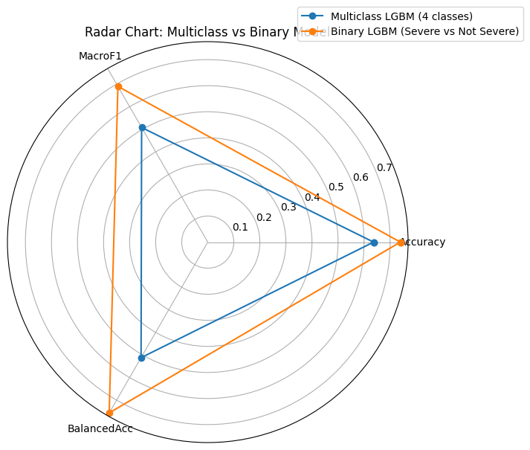
- Binary model forms a larger, more balanced polygon, indicating strong performance across all metrics.
- Multiclass model shows a smaller, uneven shape — reflecting difficulty in handling minority classes.
➡️ The radar chart visually confirms the binary model’s robustness and consistency.

Graph 3: Heatmap – Intensity of Scores
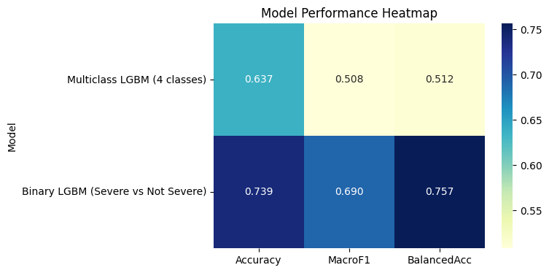
- Binary model cells are darker, indicating higher metric values.
- Multiclass model shows lighter cells, especially in balanced accuracy.
➡️ The heatmap reinforces the binary model’s superiority in both fairness and overall accuracy.

14.2 Interpretation

Multiclass Model Strengths
- Captures nuanced severity levels
- Useful for analytical dashboards and policy insights
- Performs well on dominant classes (Uninjured, Slight Injury)

Multiclass Model Limitations
- Struggles with minority class (Killed)
- Lower recall and precision for severe outcomes
- More confusion between adjacent severity levels

Binary Model Strengths
- High recall for Severe cases (0.79)
- Strong ROC-AUC (0.83)
- Simple, stable decision boundary
- Ideal for deployment in safety-critical systems

Binary Model Limitations
- Less granular — only two severity levels
- May miss subtle distinctions between injury types

14.3 Final Recommendation

🏆 Best Model for Deployment: Binary LightGBM (Severe vs Not Severe)
Why:
- Highest accuracy and balanced accuracy
- Strongest recall for severe outcomes
- Best ROC-AUC
- Most suitable for real-time risk scoring and emergency triage

📌 Multiclass Model Use Cases
- Research and policy analysis
- Injury pattern studies
- Severity stratification in post-accident reviews

Closing Statement
This project demonstrates that while multiclass severity prediction is feasible, binary severity detection is significantly more robust and deployment-ready.
The combination of LightGBM + class balancing + threshold tuning delivers a model that is both accurate and safety-oriented — prioritizing the detection of severe outcomes where it matters most.

